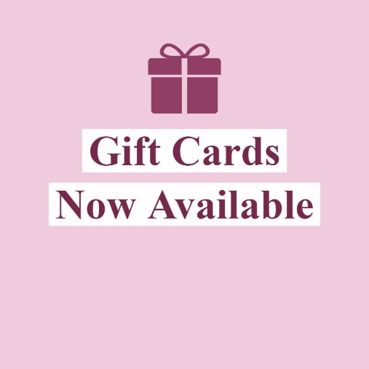

**Gift Card Qualifications Here. Buy one get one? Free gift card when you spend $30?**

**STORE NAME HERE  
Valid through here**

**Gift Card Qualifications Here. Buy one get one? Free gift card when you spend $30?**

**STORE NAME HERE  
Valid through here**

**Gift Card Qualifications Here. Buy one get one? Free gift card when you spend $30?**

**STORE NAME HERE  
Valid through here**



**Gift Card Qualifications Here. Buy one get one? Free gift card when you spend $30?**

**STORE NAME HERE  
Valid through here**

**Gift Card Qualifications Here. Buy one get one? Free gift card when you spend $30?**

**STORE NAME HERE  
Valid through here**

**Gift Card Qualifications Here. Buy one get one? Free gift card when you spend $30?**

**STORE NAME HERE  
Valid through here**

**Gift Card Qualifications Here. Buy one get one? Free gift card when you spend $30?**

**STORE NAME HERE  
Valid through here**

**Gift Card Qualifications Here. Buy one get one? Free gift card when you spend $30?**

**STORE NAME HERE  
Valid through here**

**Gift Card Qualifications Here. Buy one get one? Free gift card when you spend $30?**

**STORE NAME HERE  
Valid through here**

**Gift Card Qualifications Here. Buy one get one? Free gift card when you spend $30?**

**STORE NAME HERE  
Valid through here**

**Gift Card Qualifications Here. Buy one get one? Free gift card when you spend $30?**

**STORE NAME HERE  
Valid through here**

**Gift Card Qualifications Here. Buy one get one? Free gift card when you spend $30?**

**STORE NAME HERE  
Valid through here**